**12B – Reflection & Transmission**

**(Oblique Incidence)**

**Topics:** Reflection and transmission, boundary conditions, complex exponentials.

**Summary:** Students begin by expressing in exponential notation the boundary condition on the parallel components of the electric field for an EM plane wave at oblique incidence to the interface between vacuum and a material. After finding the phase shift for the reflected wave, students should conclude that the components of *k* for each of the waves that are parallel to the boundary must match if the equation is true all along the boundary. The remaining tasks connect the angles of reflection and transmission to index of refraction for the material.

**Written by:** Charles Baily, Michael Dubson and Steven Pollock.

**Contact:** Steven.Pollock@Colorado.EDU

**Comments:** Warning (!): Portions of this tutorial have not been validated or field-tested, but we expect students to be able to finish these tasks in around 30 minutes. A somewhat different version was used in our class, and the tasks related to representations in the complex plane are new. The tasks in this tutorial have been constructed with the assumption that students have completed the tutorial on R&T for normal incidence (#12A); if not, the more abbreviated tasks herein will be more challenging, since they are not scaffolded in the same way as in the prior tutorial. It’s important that students find the correct final equation on pg. 1, since it will be used in subsequent tasks. The vectors in the diagrams all have the correct proportions, so it is important that students can justify their answers on the final page in terms of the reduced wave speed, and are not simply judging from the diagram.

**A.** An electromagnetic plane wave traveling through vacuum in the  (i.e.,  & no propagation in the *y*-direction) is incident upon a material at an angle  relative to the *z*-axis.

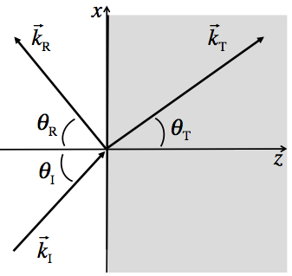

With the incident wave linearly polarized in the *y*-direction (out of the page), the electric fields of the incident, reflected and transmitted waves can each be represented by the following complex exponentials:







According to Faraday’s Law, the parallel component of the total electric field on either side of the boundary must be the same at all times:



Use the information given to re-write this boundary condition for , using the complex exponential notation from above.

Now, write out this boundary condition for  & .

You may continue, but be sure to check your answers with an instructor.

**B.** With the *incident* E-field at  &  shown below at left, use the other axes to draw arrows representing the E-fields of the *reflected* and *transmitted* waves for the case . Be sure to label your arrows.

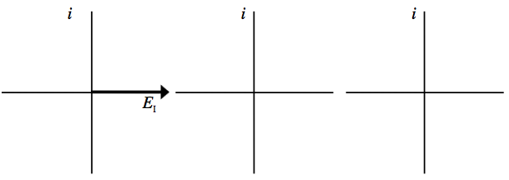

What is the phase shift  of the *reflected* wave in this case?

Use the diagram above to draw the *incident* E-field at a distance  from the origin (). Be sure to think carefully about the direction  rotates in the complex plane as *x* increases and *t* is held constant.

Boundary conditions must be satisfied everywhere along the boundary (not just at ). We can solve for  in the time-independent equation from the first page:



For this equality to hold at all times, what must be true about the quantities  and ? Briefly explain your reasoning.

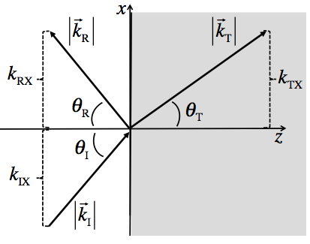**C.** According to the diagram:







Keeping in mind that the incident and the reflected wave are both traveling in vacuum, what is the relationship between  & ? Briefly explain your reasoning.

What is  in terms of the components of ?

Determine the following ratio for the incident and transmitted waves:



Keeping in mind that the transmitted wave is traveling slower than the speed of light in vacuum, which of the following is true? How does the angle of transmission compare with the angle of incidence in this case?

  